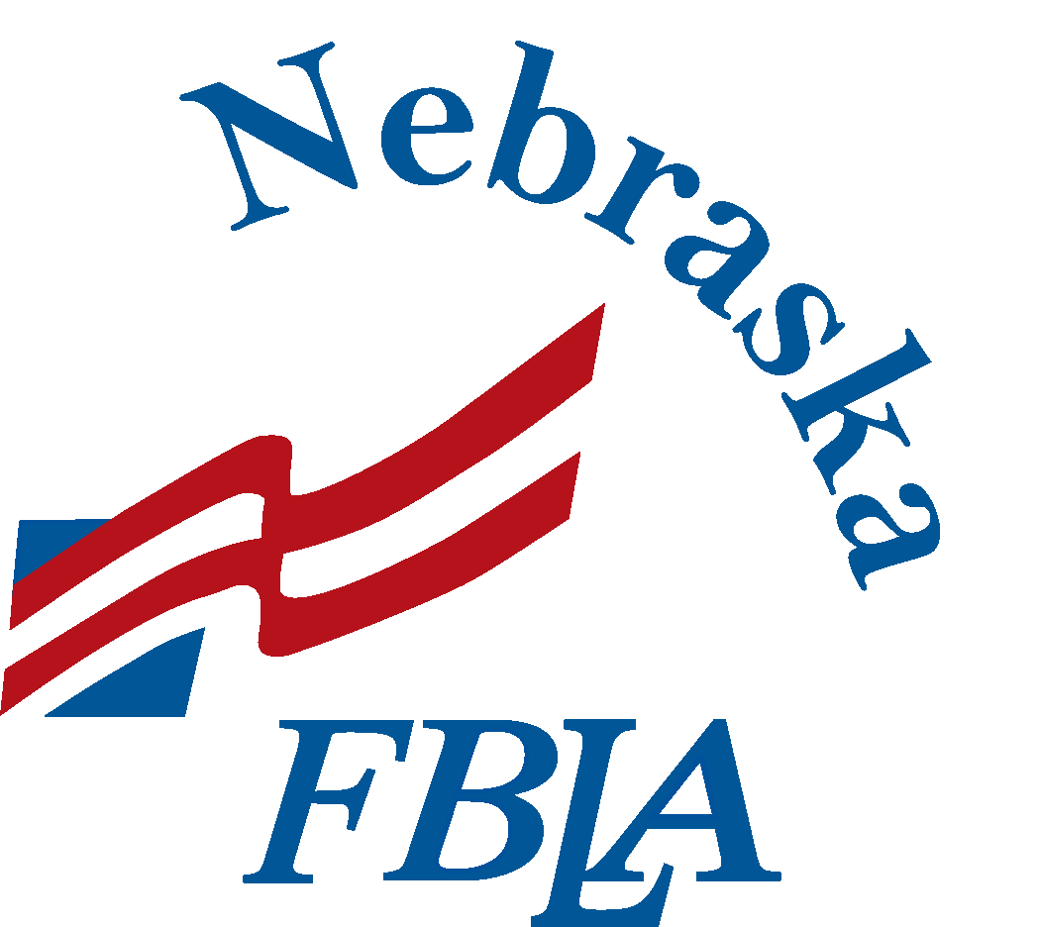
Nebraska Future Business Leaders of America
Tally It Up!
Community Service Hours Reporting Form
DEADLINE: March 1, 2019

Please email this form to the Nebraska FBLA State Reporter at reporter@nebraskafbla.org by March 1.

Chapter |  |  | Adviser(s)

 | Project Name | Date | Number of  Students | Hours  Worked | Total Hours  of Project
 | Example: Trash Pickup | 7/27/19 | 25 | 2 | 50
1
2
3
4
5
6
7
8
9
10
11
12
Total Service Hours (March 2, 2018 to March 1, 2019)

