The goals of FBLA are to:
How do I get involved?

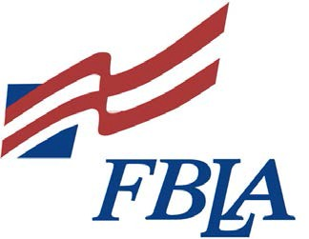
Nebraska
Future Business Leaders of America
Business
Partnerships
- Develop competent, aggressive business leadership

For further information contact the business education department at your high school.
- Strengthen students’ confidence
in themselves and their work

- Create more interest in and understanding of the American business enterprise system

- Encourage the development of individual projects that contribute to home, business, and community improvements

- Develop character, prepare for useful citizenship

- Encourage and practice efficient money management
•
Encourage scholarship and
promote school loyalty
or contact:
- Help students’ occupational
goals
•
Facilitate the transition from
school to work
Nebraska FBLA PO Box 95072
Lincoln, NE 68509-5072
402-471-4865

What is FBLA? What are the activities of FBLA chapters?
How would your partnership with FBLA benefit your business?

Nebraska Future Business Leaders of America (FBLA) prepares students for leadership and career opportunities. It is the largest student business organization in Nebraska with over 5,000 members in more than 140 secondary and middle schools.

Offering innovative leadership and career development programs, FBLA brings students and business together in a positive working relationship.

FBLA offers members fun, challenging and rewarding projects as members work toward reaching their potential. Working with local businesses, community leaders, and the public, members gain business experience and knowledge.

Career goals are enhanced for members through workshops, conferences, speakers and business tours. Making connections with business professionals and community leaders is a valuable part of the FBLA experience.

Professional Opportunities
Professional activities provide members with a business connection for their future while increasing student business skills and knowledge. Members also gain valuable career awareness and assistance with setting career goals. Activities include guest speakers, panel discussions, visits to business and industry and shadowing experiences.

Leadership Development
One of the most important goals of Nebraska FBLA is leadership development. FBLA members lean valuable life skills in areas such as teamwork and communication.

Service
Serving others is a focus of the FBLA program. Nebraska members contribute 40,000 hours annually to their communities. FBLA is the state’s largest youth volunteer force for March of Dimes. Local chapters also choose projects to meet the needs of their community

.

Your business partnership provides you with:

- Direct involvement with schools
- Opportunity to model professionalism
- Community visibility
- Students to serve as interns
- Quality employees

How can you get involved?

You can positively impact today’s youth by partnering with your FBLA chapter. Your business could provide:

- Job shadowing opportunities
- Mentors
- Resource speakers
- Career education
- Field trips
- Mock job interviews
- Competitive event judges
- Equipment and supplies
- Educational materials
- Financial contributions

